GEOSPATIAL ANALYTICS PROJECT

GROUP 6  
hASEENA BANU & NURULHUDA

### Introduction

Problem— How do we access how friendly our current public transport system and public traffic light system are towards people with walking difficulties and wheelchair community?

Motivation— Our motivation of this project is with Smart Nation in mind and identifying opportunities for optimizing operation efficiency of the infrastructure in the URA planning namely the traffic-light and public transport system. The target group that we are addressing is residents with mobility impairment such as the aged population as well as wheelchair bound.

Green Man + is an initiative by the Land Transport Authority (LTA) which addresses the needs of elderly pedestrians and Persons with Disabilities (PWD). Elderly pedestrians and PWD are entitled to 13 seconds more of green man time depending on the size of the road when they tap the CEPAS-compliant senior citizen concession card or PWD concession card at pedestrian crossings fitted with Green Man +.

### Project Description

Our application seeks to provide the following:

1. see how accessible are the transportation facilities for the people with walking disabilities such as the aged and wheelchair bound community
2. accesses how wheelchair friendly the transportation facilities are in the different subzones in Singapore.
3. analyse every road segment at CBD to determine the ideal timing for pedestrians with walking difficulties to cross the road

The key aim of the project is to show that the open source web API can be easily utilized to build an application that can help us understand how friendly the transportation services are in Singapore to people with walking difficulties.

### Related Work

* Bus timing apps
* MRT routes
* Wheelmap

### Approach & Early Prototype

Base data

* MRT Stations (look at how many MRT with disabled facilities)
* Busstops (look at how many Busstops with disabled facilities)
* Age group density
* Traffic light location.
* Road map at CBD area
* Wheelchair friendly pickup areas

Demographic data

* Aged people with mobility impairment & what is their average walking speed? What is the comfortable speed they should have.
* PWD & what is their average mobility speed? What is the comfortable speed they should have.

Generic Application

* Allows user to upload relevant data/layers in the app – with disabled facilities/disabled people
* How accessible locations are from the transport systems—e.g. getting into the MRT(don’t have many places for wheelchair- bound people)

Application modification

* Allow to analyse every road segment (road segment data—e.g. 10m width, what is the recommended timing to have).
* Traffic planner can analyse and come out with the proper timing for each road segment (recommend) – take two ends of the road(traffic lights) and split them to get the distance.

### Key Technical Challenges

Description of approaches or storyboard of how you plan to address the challenges.

### Future Work

A description of how your system could be extended or refined. (Maybe the jaywalking idea can go here?? Lol)

### Project milestone

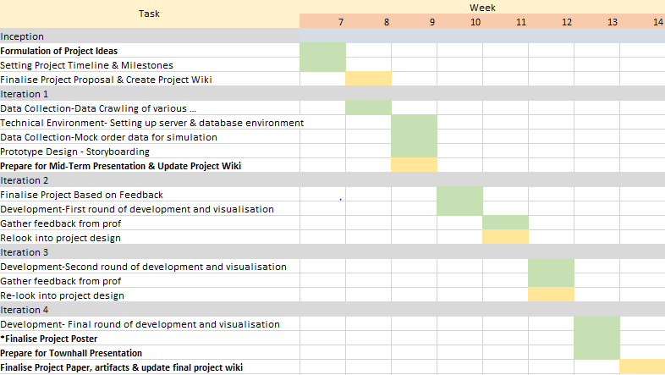

+ description of what each person will be working on

### References

<https://data.gov.sg/dataset/27de4b39-fccd-4bfe-910a-86076edaae92/resource/9285c1a1-ac49-495c-b9cf-3189611cff04> -Residents by subzone age group

<https://www.mytransport.sg/content/mytransport/home/dataMall.html> -Busstop location, traffic light, train station, train station exit

<https://www.msf.gov.sg/research-and-data/Research-and-Statistics/Pages/Programmes-for-Persons-with-Disabilities.aspx>

<https://data.gov.sg/dataset/secondary-schools-with-special-needs-facilities-resources>

<https://www.msf.gov.sg/Pages/default.aspx>